MobileTestingScenario_runTestScenario_Instance3_06-Apr-2016_07-57-42_AM_Staging_Page_Navigation.png

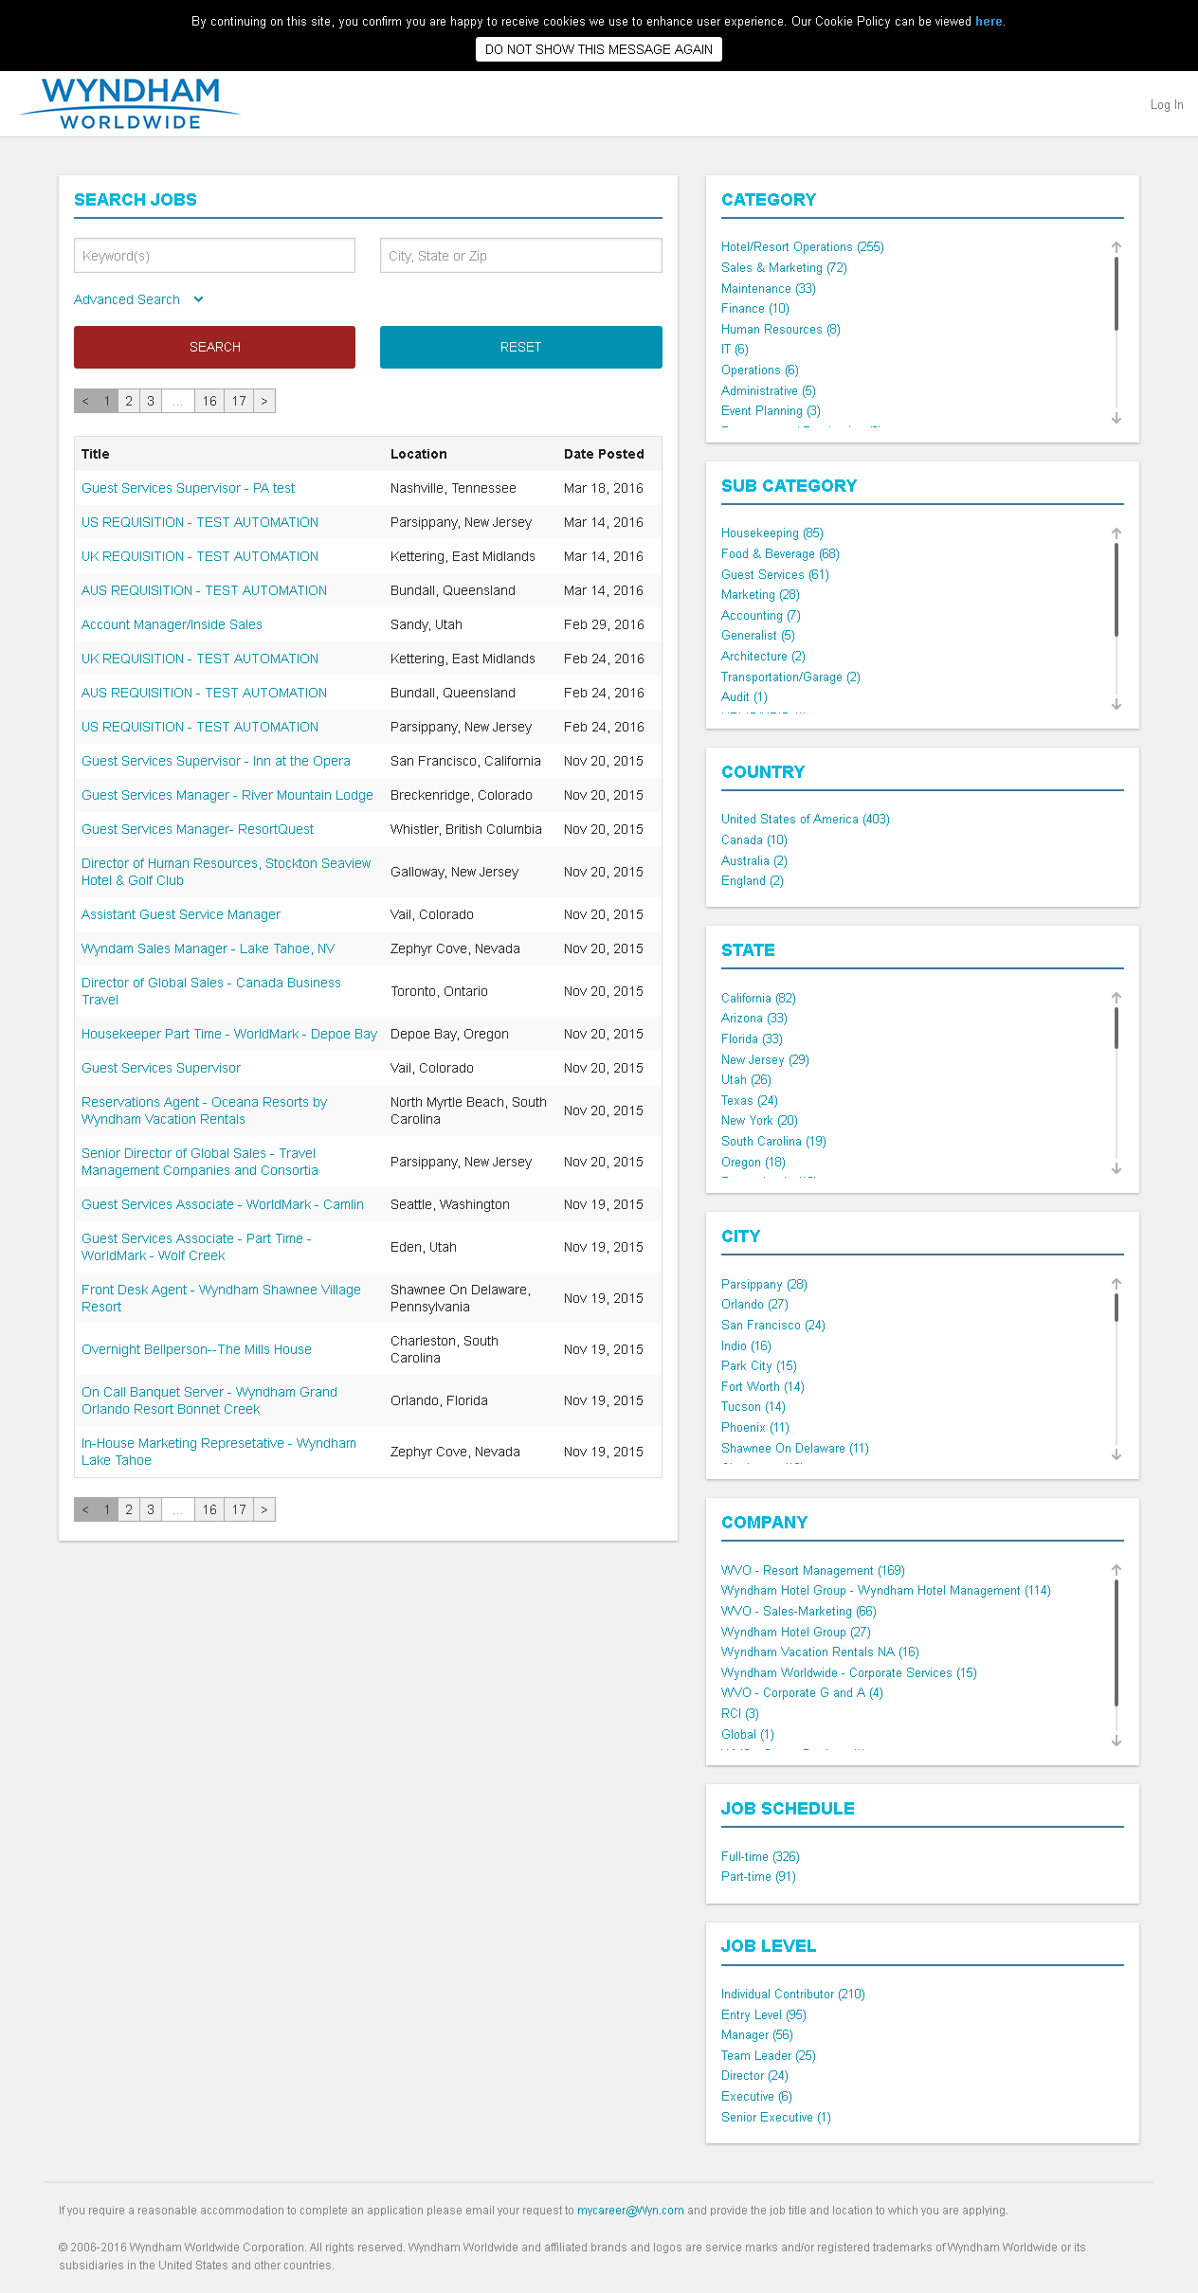

MobileTestingScenario_runTestScenario_Instance3_06-Apr-2016_07-58-27_AM_Create_Account.png

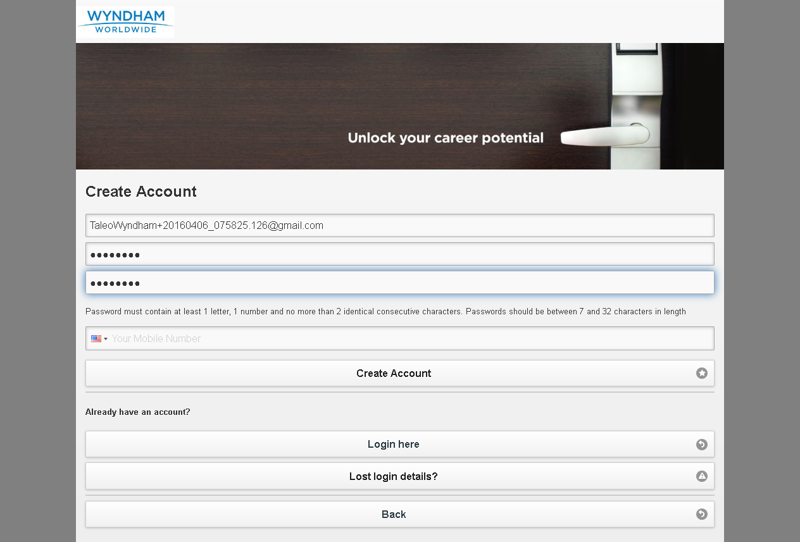

MobileTestingScenario_runTestScenario_Instance3_06-Apr-2016_07-58-46_AM_Create_Account.png

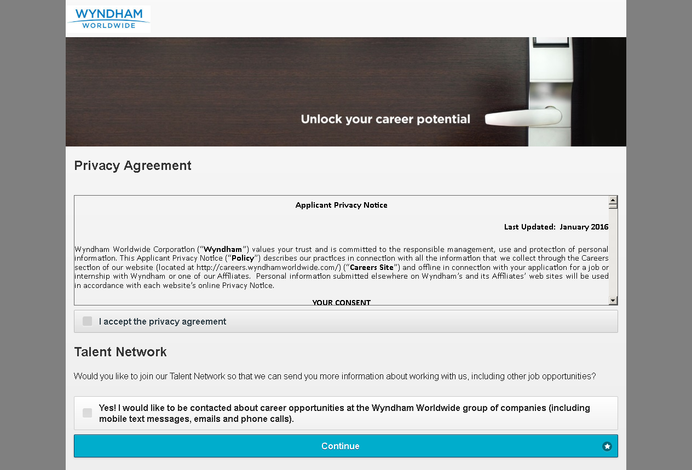

MobileTestingScenario_runTestScenario_Instance3_06-Apr-2016_07-58-47_AM_Continue.png



MobileTestingScenario_runTestScenario_Instance3_06-Apr-2016_07-58-51_AM_privacyAgreement.png

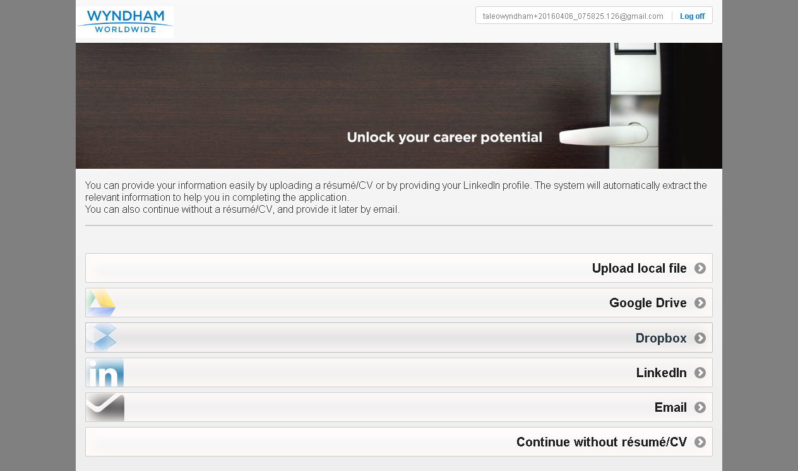

MobileTestingScenario_runTestScenario_Instance3_06-Apr-2016_07-58-52_AM_Resume_Option.png

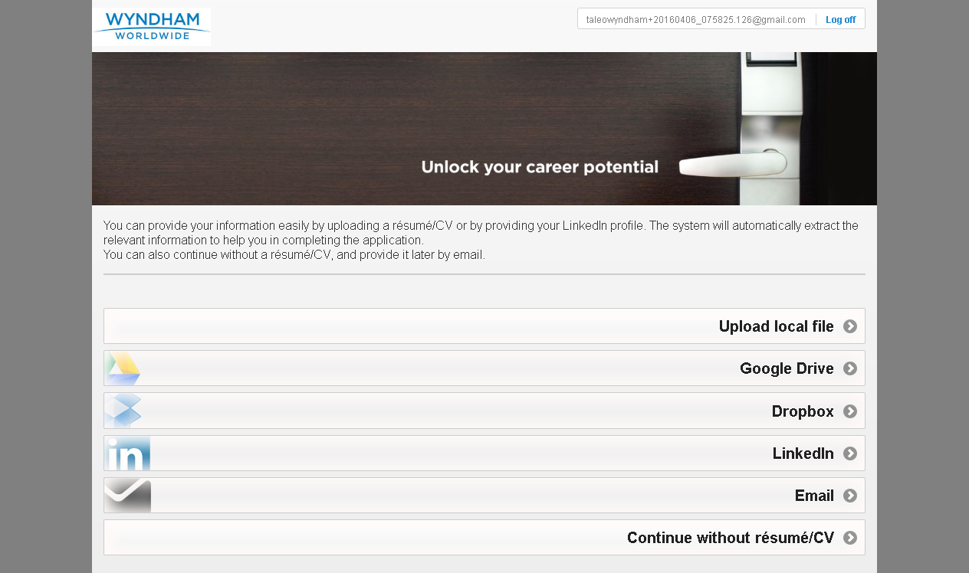

MobileTestingScenario_runTestScenario_Instance3_06-Apr-2016_07-58-59_AM_Dropbox_Option.png

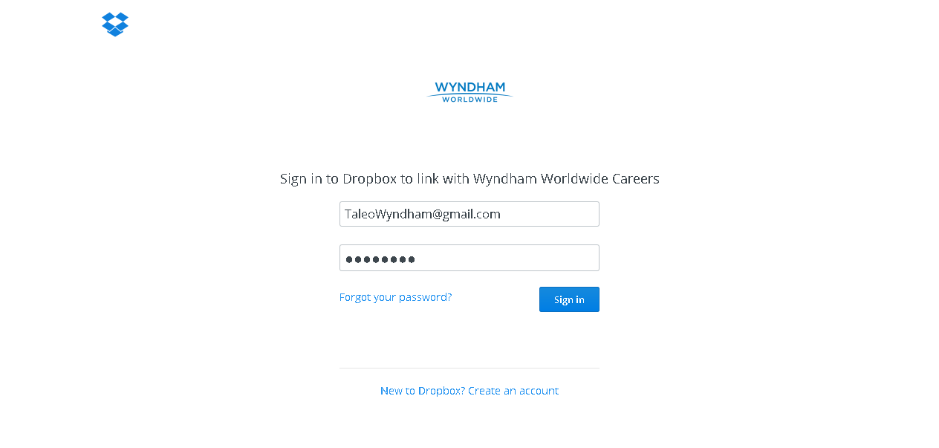

MobileTestingScenario_runTestScenario_Instance3_06-Apr-2016_07-59-12_AM_Dropbox_Option.png

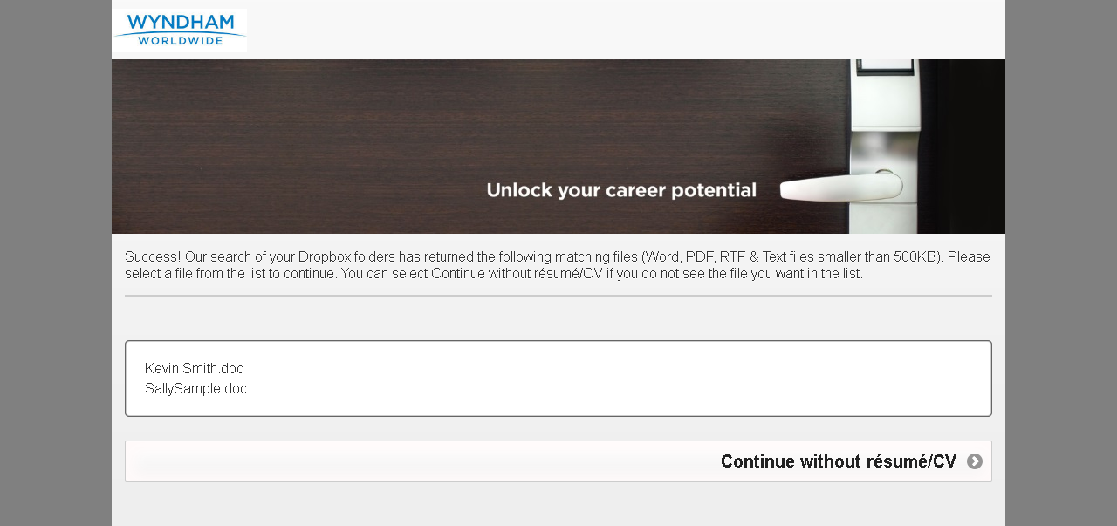

MobileTestingScenario_runTestScenario_Instance3_06-Apr-2016_07-59-17_AM_Dropbox_Option.png

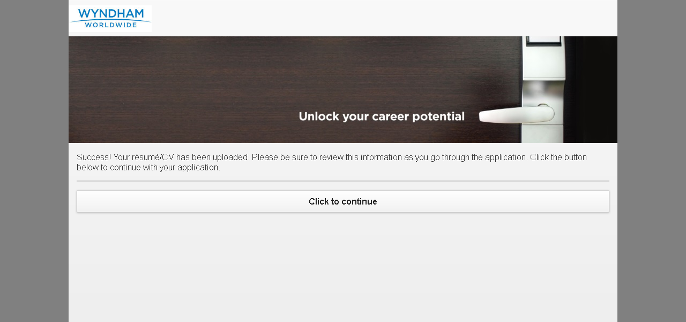

MobileTestingScenario_runTestScenario_Instance3_06-Apr-2016_08-00-00_AM_Tell_us_about_yourself.png

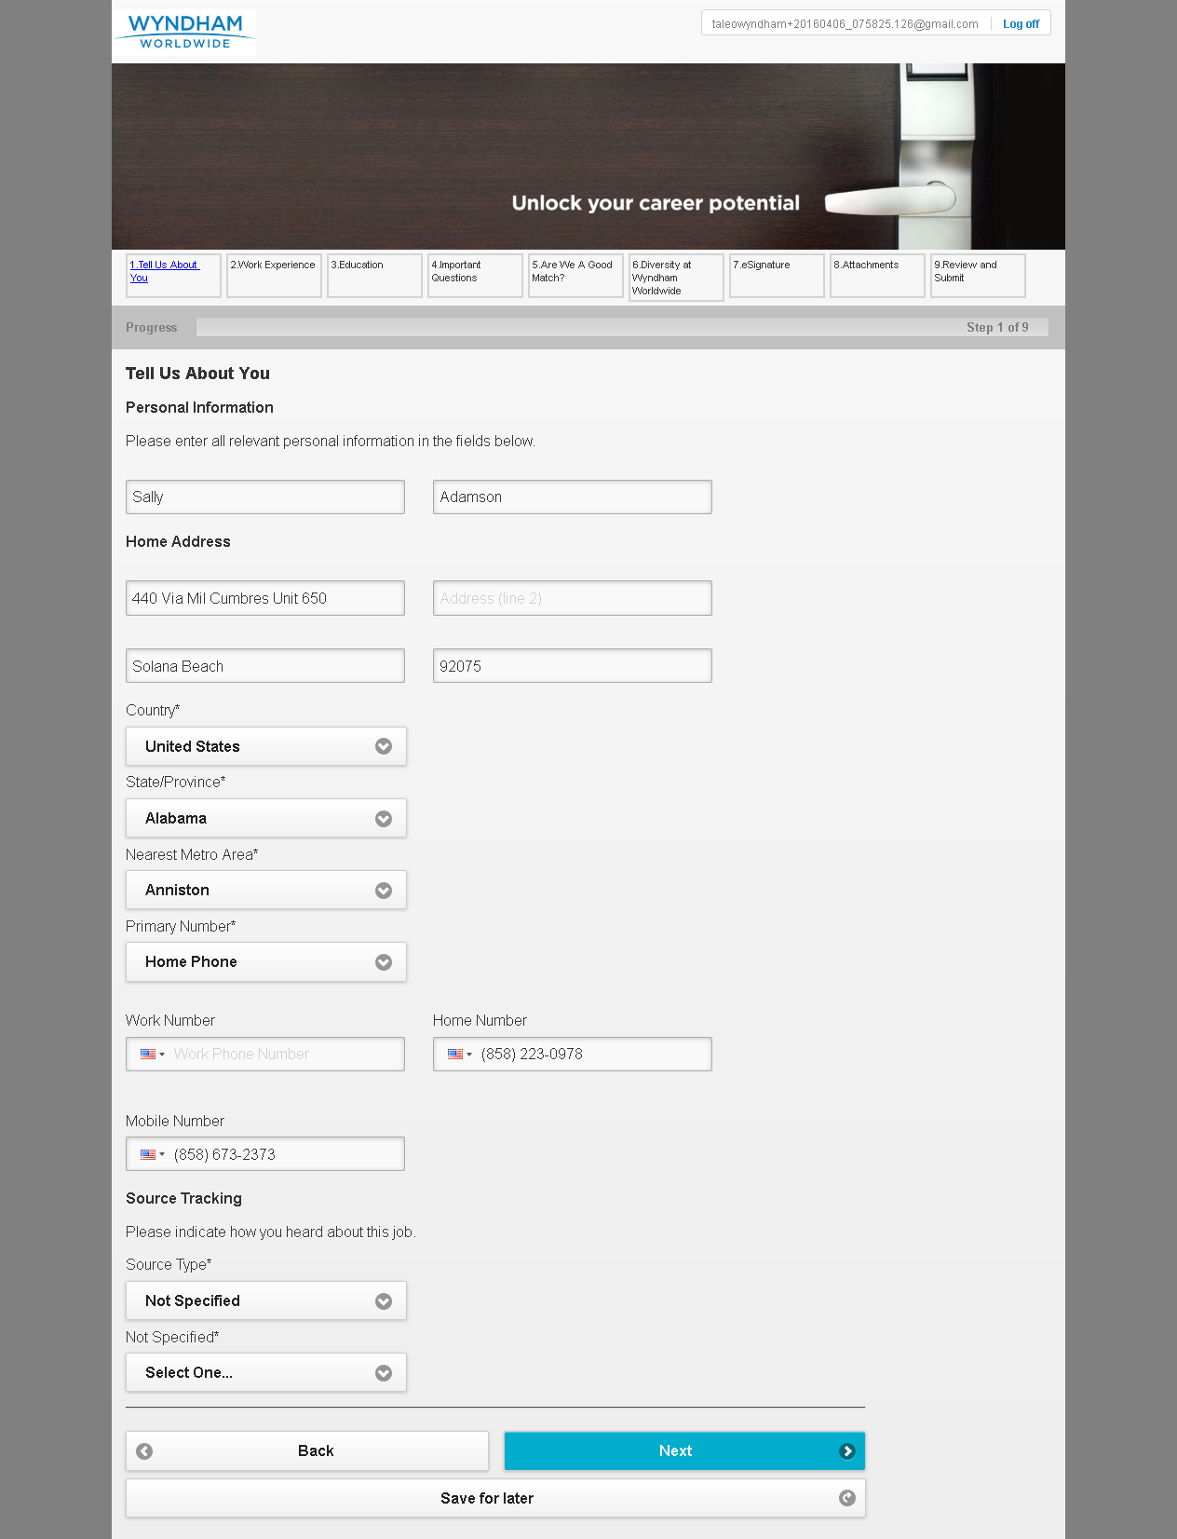

MobileTestingScenario_runTestScenario_Instance3_06-Apr-2016_08-00-11_AM_Tell_us_about_yourself.png

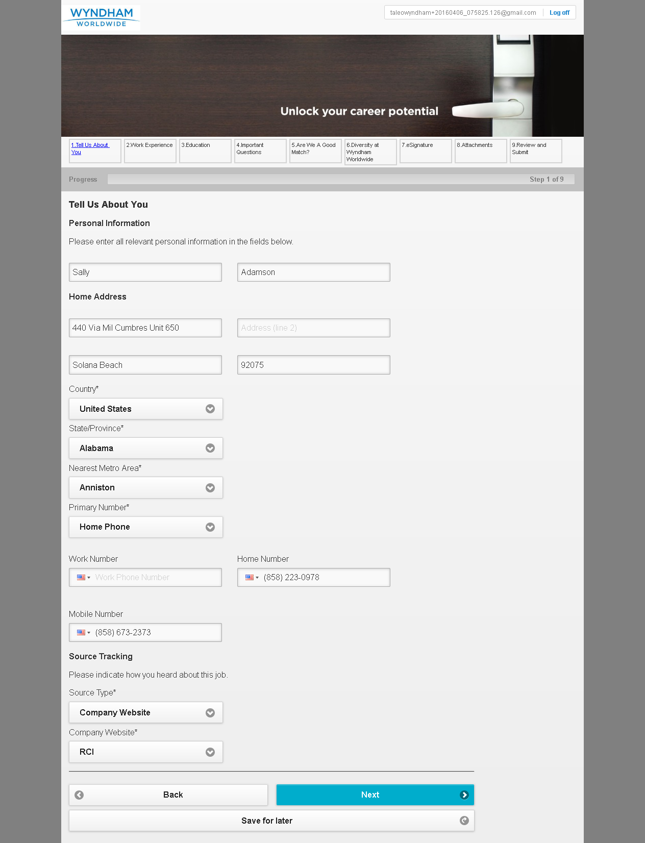

MobileTestingScenario_runTestScenario_Instance3_06-Apr-2016_08-00-22_AM_Work_Experience.png

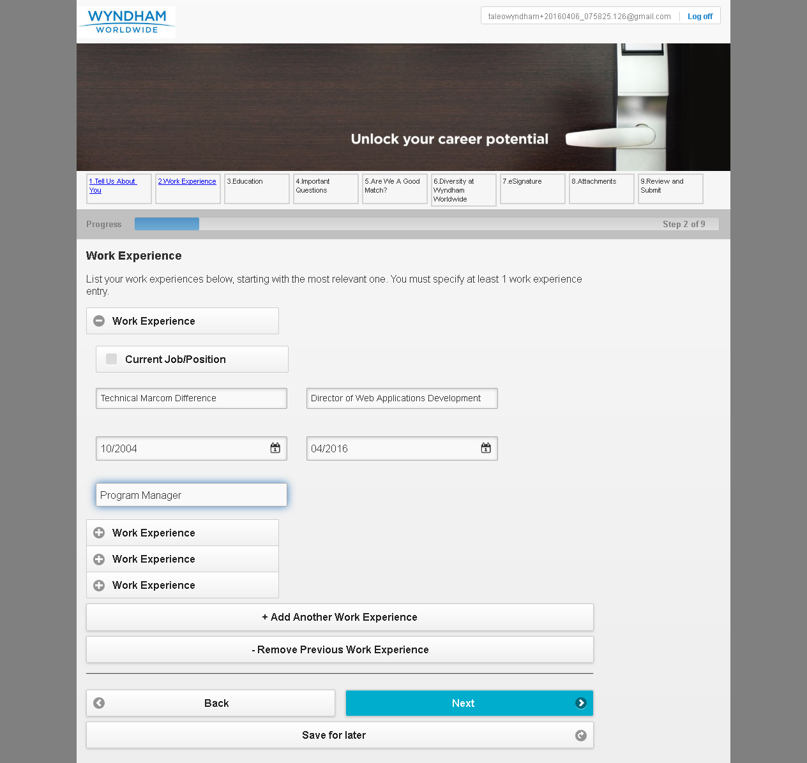

MobileTestingScenario_runTestScenario_Instance3_06-Apr-2016_08-00-39_AM_Education.png

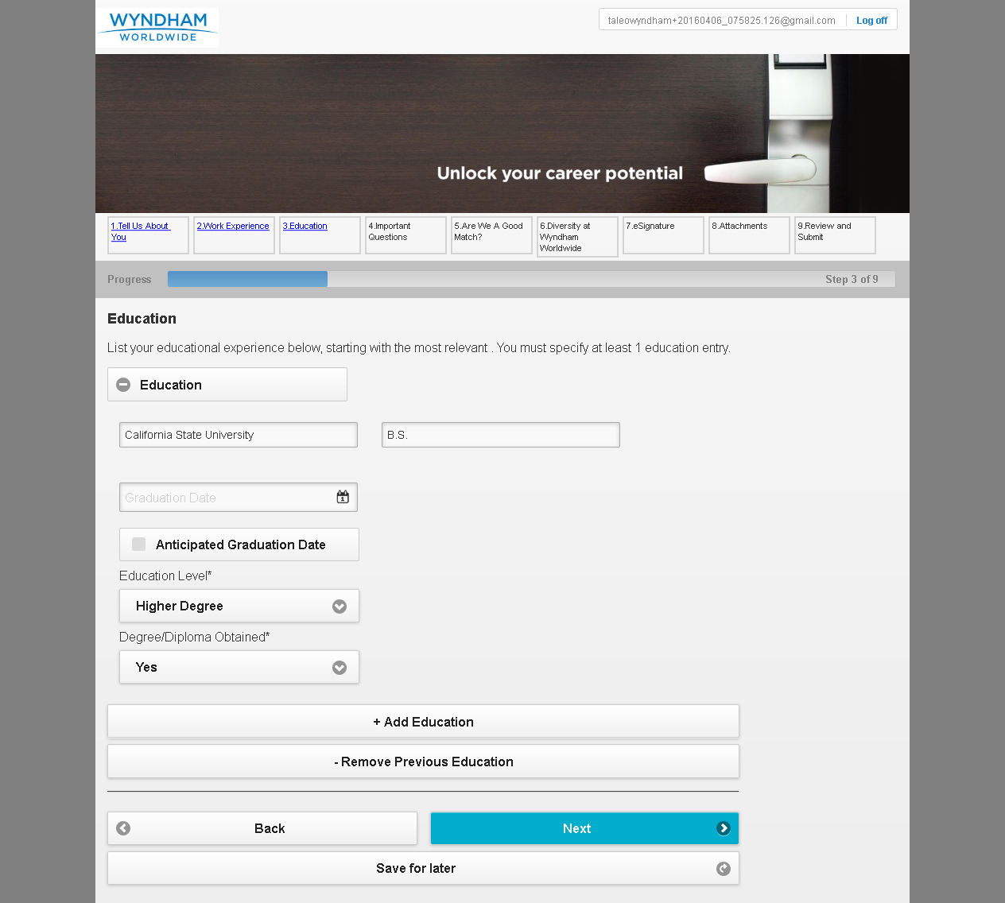

MobileTestingScenario_runTestScenario_Instance3_06-Apr-2016_08-00-46_AM_Questions.png

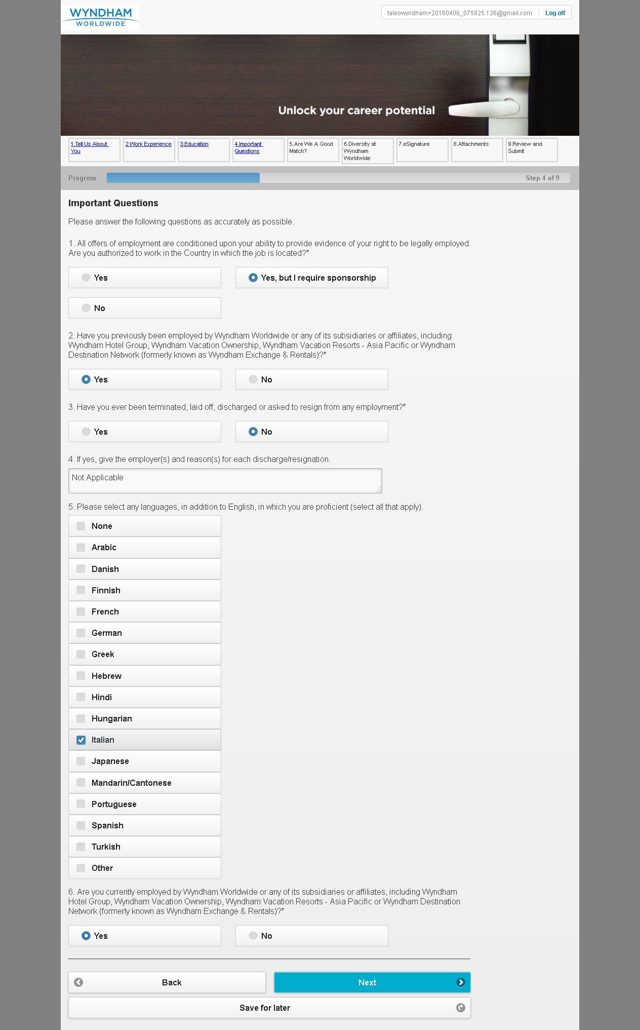

MobileTestingScenario_runTestScenario_Instance3_06-Apr-2016_08-00-58_AM_Are_we_good_Match.png

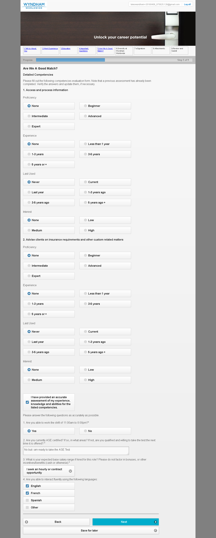

MobileTestingScenario_runTestScenario_Instance3_06-Apr-2016_08-01-21_AM_Diversity.png

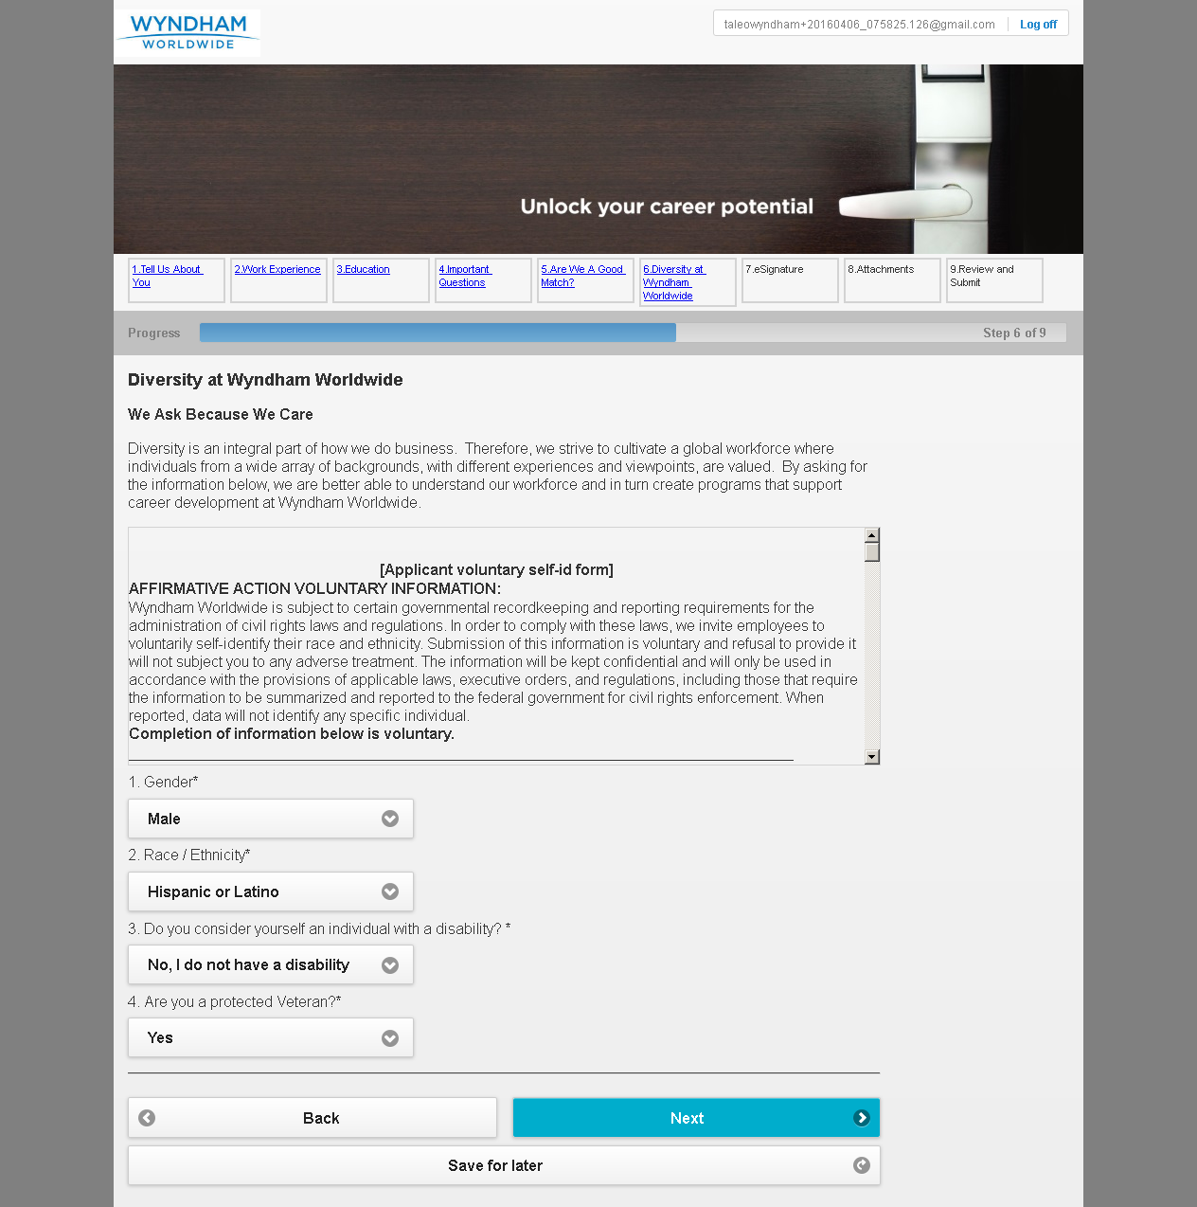

MobileTestingScenario_runTestScenario_Instance3_06-Apr-2016_08-01-28_AM_eSignature.png

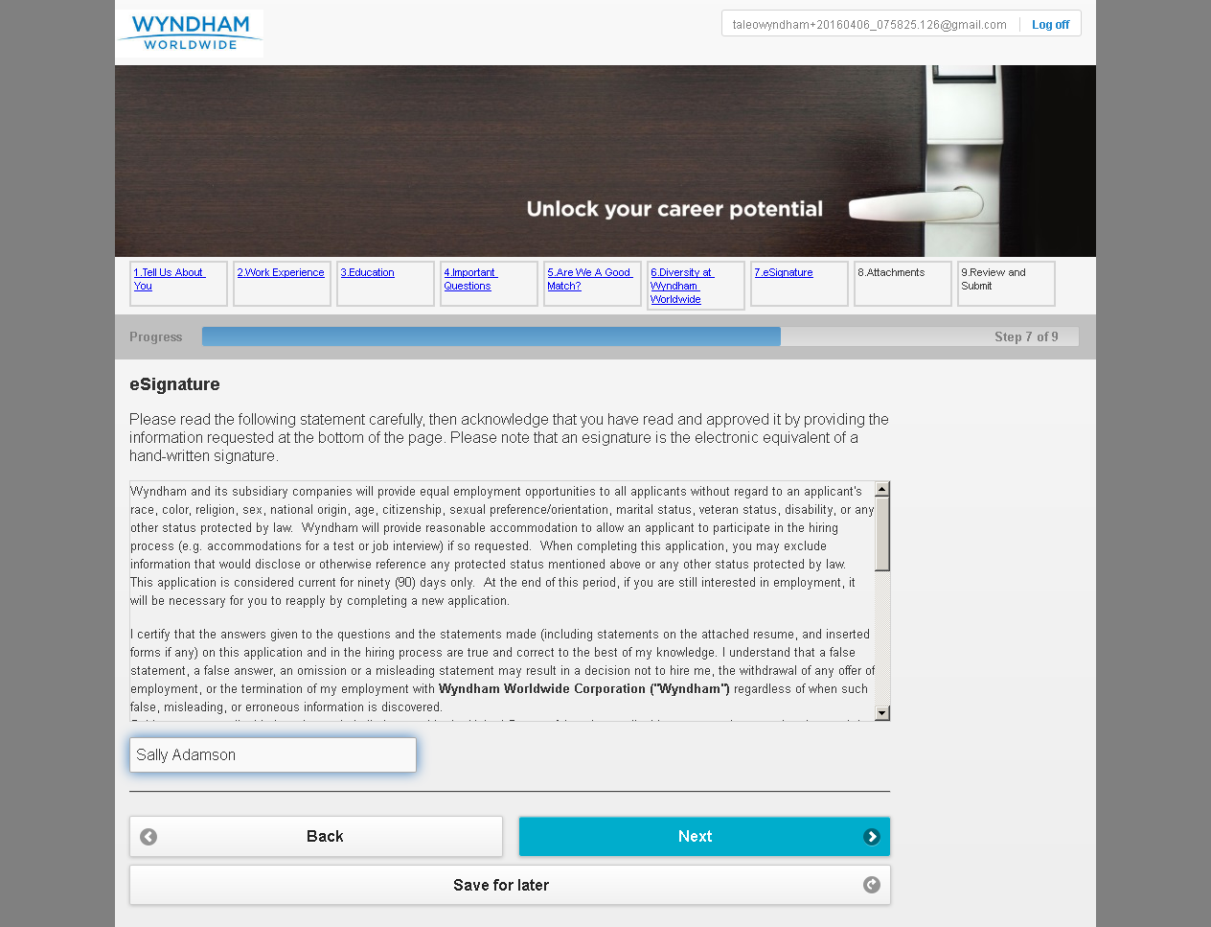

MobileTestingScenario_runTestScenario_Instance3_06-Apr-2016_08-01-34_AM_Attachment.png

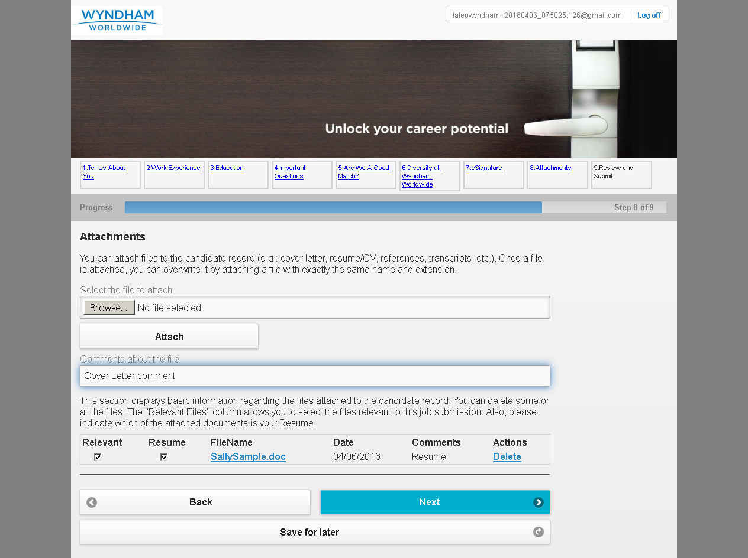

MobileTestingScenario_runTestScenario_Instance3_06-Apr-2016_08-01-45_AM_Review_and_Submit.png

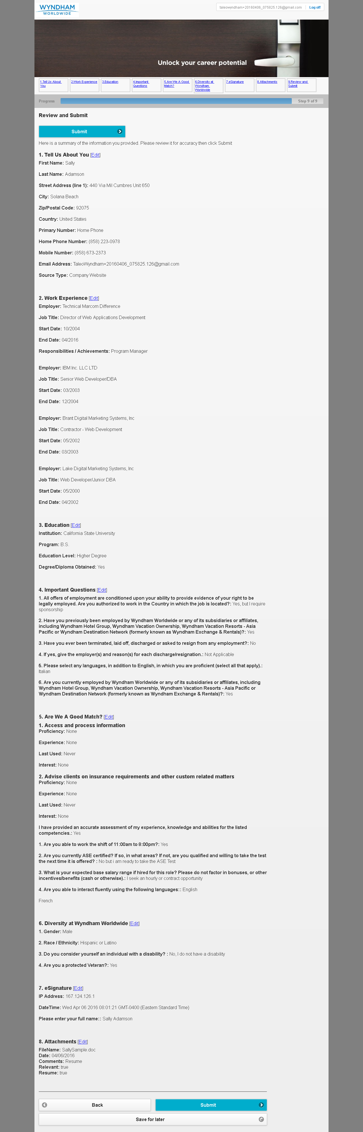

MobileTestingScenario_runTestScenario_Instance3_06-Apr-2016_08-01-59_AM_Application_Completed.png

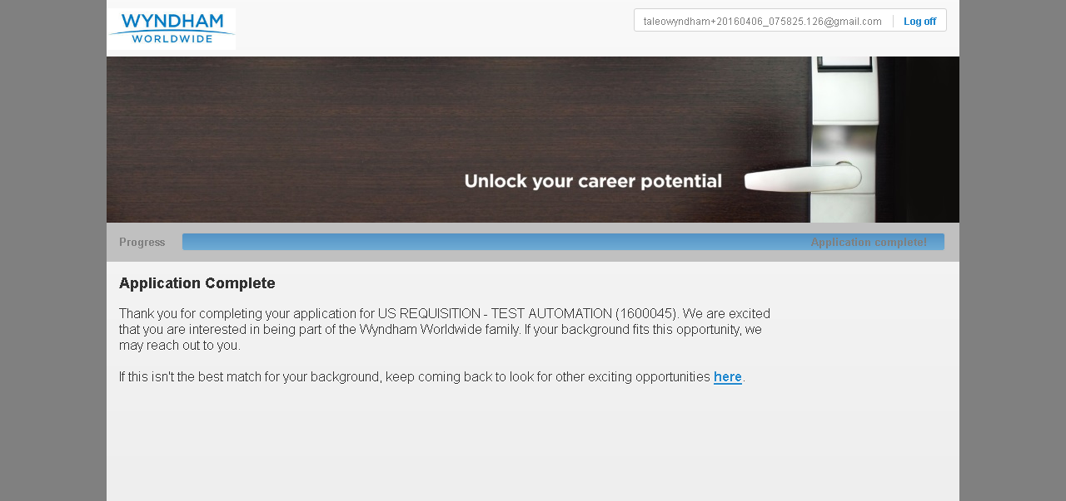

MobileTestingScenario_runTestScenario_Instance3_06-Apr-2016_08-02-12_AM_CRM_Loop_Validation.png

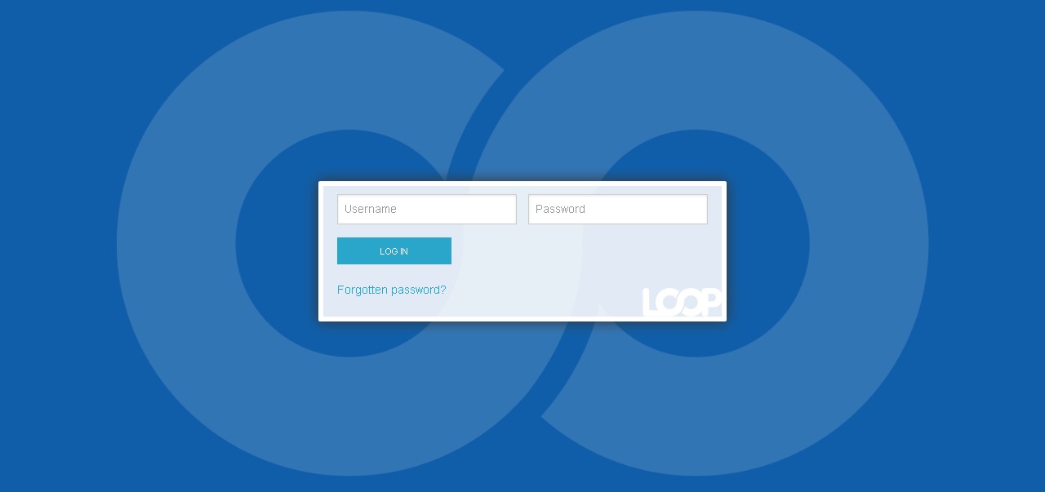

MobileTestingScenario_runTestScenario_Instance3_06-Apr-2016_08-02-21_AM_CRM_Loop_Validation.png

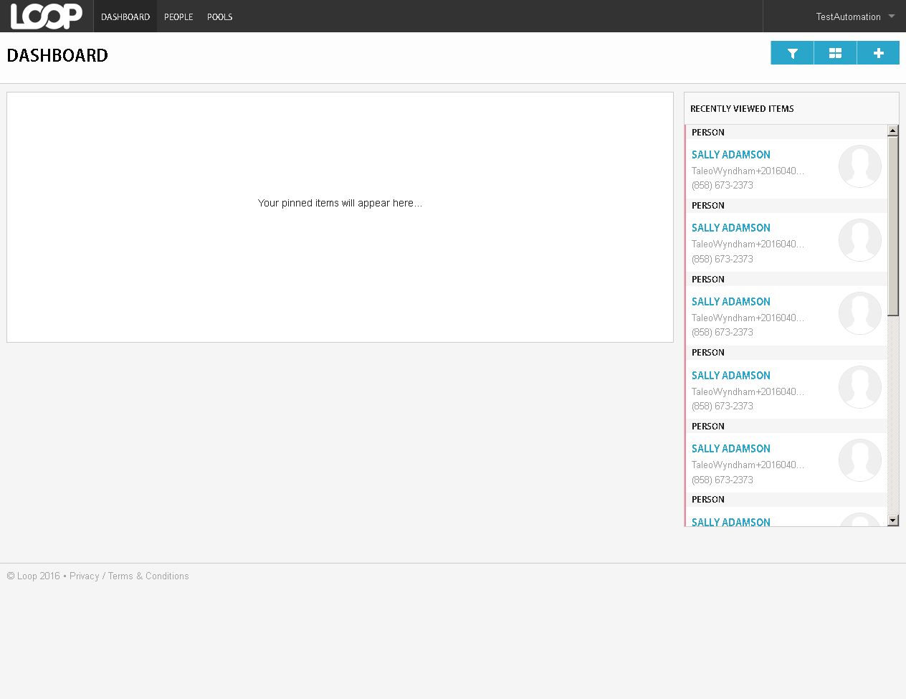

MobileTestingScenario_runTestScenario_Instance3_06-Apr-2016_08-02-42_AM_CRM_Loop_Validation.png

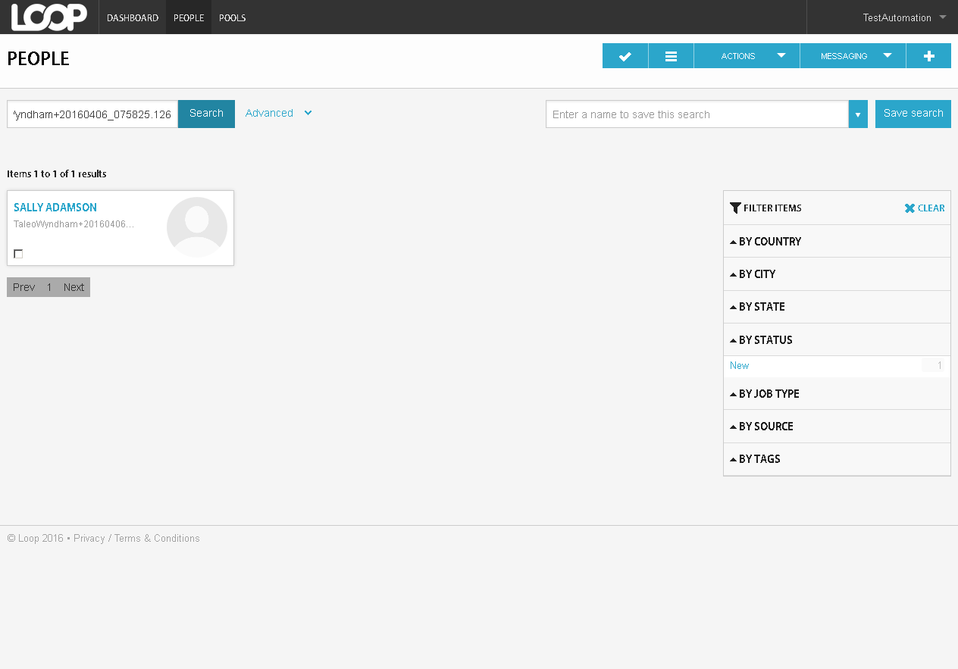

MobileTestingScenario_runTestScenario_Instance3_06-Apr-2016_08-02-49_AM_CRM_Loop_Validation.png

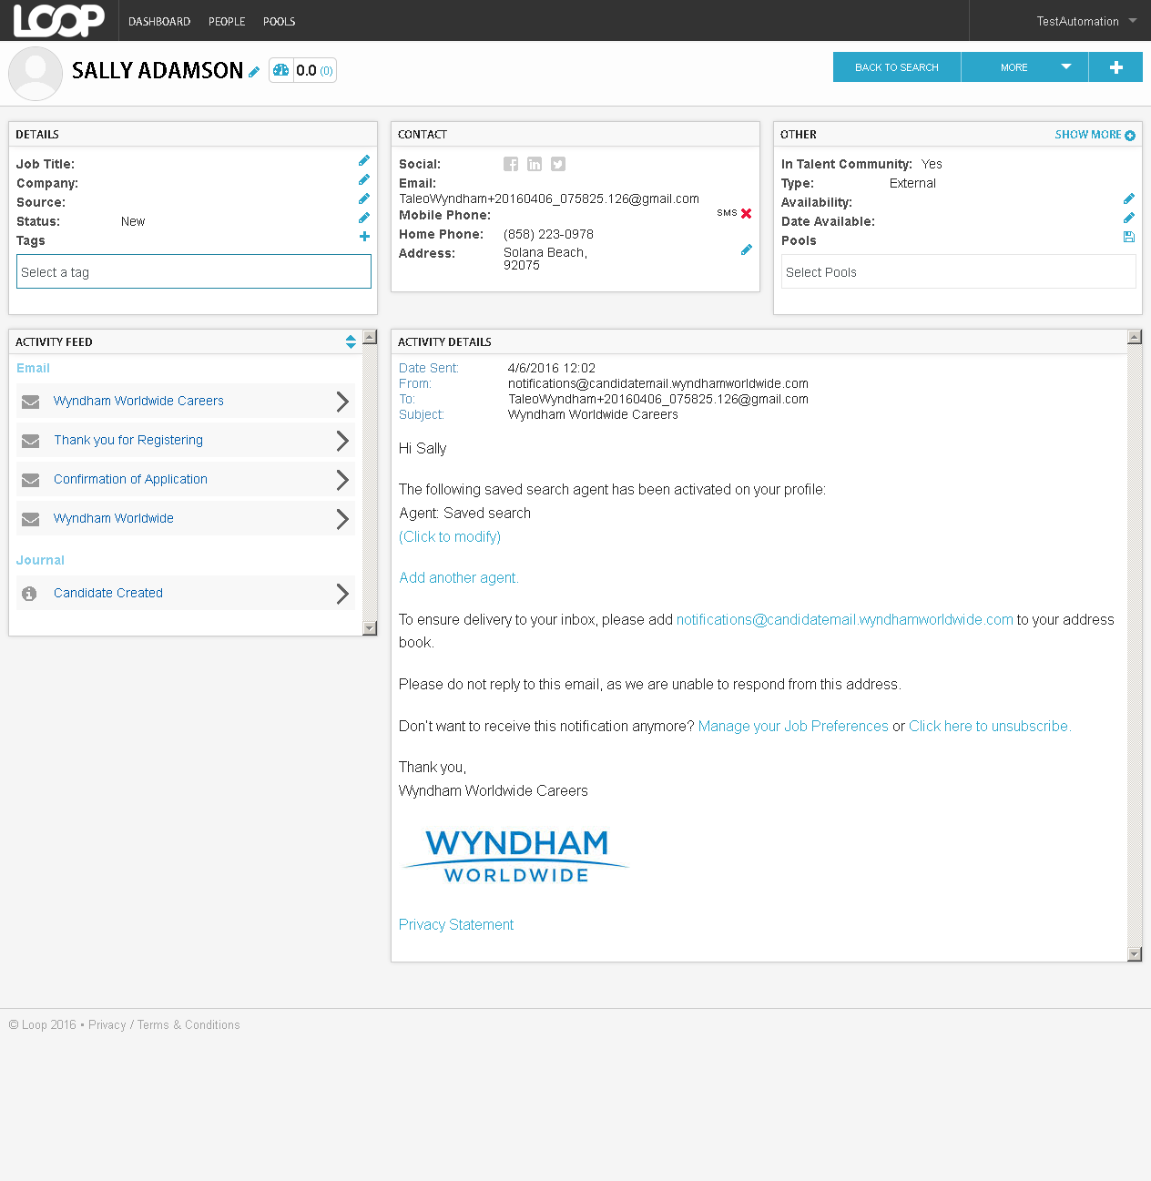

MobileTestingScenario_runTestScenario_Instance3_06-Apr-2016_08-02-54_AM_CRM_Loop_Validation.png

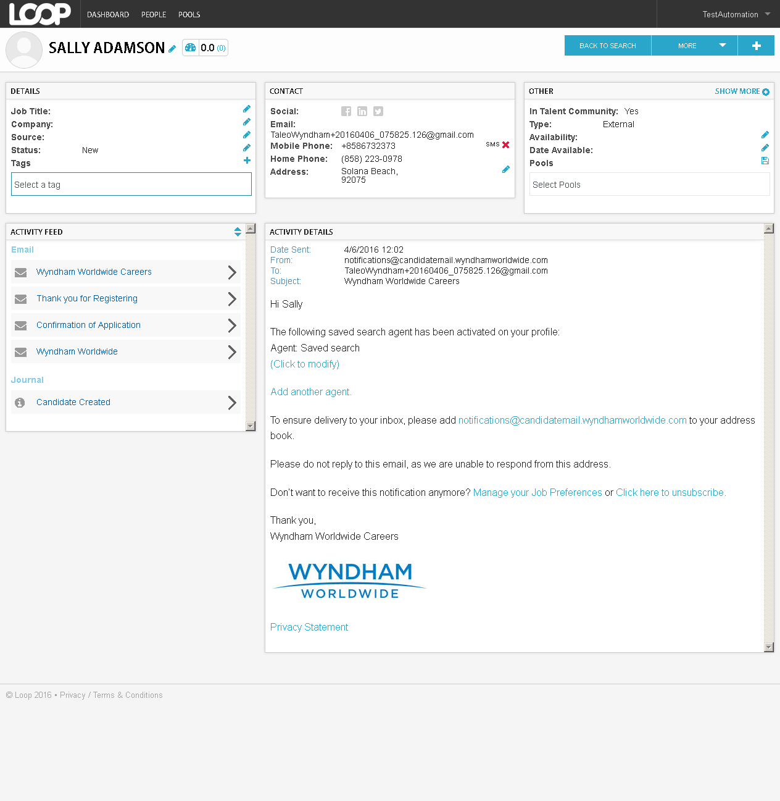

MobileTestingScenario_runTestScenario_Instance3_06-Apr-2016_08-02-55_AM_CRM_Loop_Validation.png



MobileTestingScenario_runTestScenario_Instance3_06-Apr-2016_08-03-00_AM_Login_Page.png



MobileTestingScenario_runTestScenario_Instance3_06-Apr-2016_08-03-23_AM_Candidate_Search_Page.png

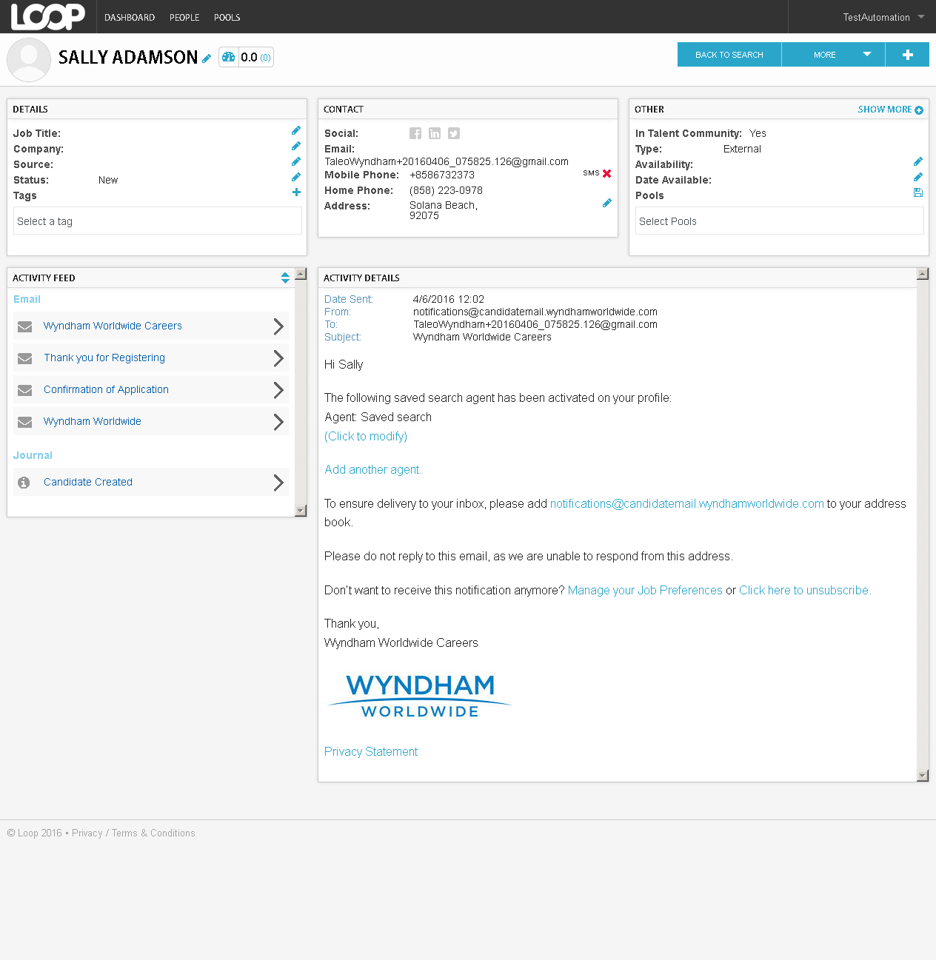

MobileTestingScenario_runTestScenario_Instance3_06-Apr-2016_08-03-43_AM_Candidate_Home.png



MobileTestingScenario_runTestScenario_Instance3_06-Apr-2016_08-04-14_AM_Attachhments.png

